**Frog IGF-1 Genetic Engineering Kit**

**DO THIS IMMEDIATELY**

Once you receive this kit you need to place 3 frogs in each habitat container with moss that covers half the bottom of the container. Add a microcentrifuge tube of the water treatment solution to 300mL water and mix thoroughly. Dump 100mL of the water into the container and allow it to soak into the moss. With gloves on your hands add 3 frogs to each cage. Afterward, weigh out 0.6g (try to keep within 0.58-0.65g) of crickets and add to each container. Make sure the frogs are placed in a location where the temperature stays between 65F - 85F(20C - 30C). Feed the frogs once a day, don’t worry if they don’t go after the crickets immediately they can sometimes eat at night. If the crickets start to build up in the cage give them a day or two to eat the crickets before adding more. Make sure you always do the same thing in both cages i.e. if you don’t feed one cage because of a build up of crickets don’t feed the other either.

**Frog IGF-1 Genetic Engineering Kit**

**Contents**

6 Green Tree Frogs(Hyla cinerea)

2 Cages

Moss

Benzocaine anesthetic

Water treatment solution

Live crickets

10 syringes of 30ug DNA mixed with [transfection reagent](https://patents.google.com/patent/US20010004636)

10 syringes of PBS

Scale

Plastic container with lid

10 pairs of Nitrile gloves

**Summary**

This kit teaches how to perform gene therapy experiments on healthy organisms in order to modify their physical traits and characteristics. These genetic modifications are made using extra DNA called plasmids, that are added to the cells of the organisms. Because there is no direct genome changes there is no risk of the traits being passed onto offspring.

In this kit you will be adding extra copies of a gene called Insulin like Growth Factor 1(IGF-1). The IGF-1 gene activates growth hormones inside the animal and these growth hormones should cause the organism to grow larger than an animal that did not receive the same treatment.

Find this document at: <https://goo.gl/BTvwcN>

# 



Schedule

|  |  |  |  |  |  |  |  |
| --- | --- | --- | --- | --- | --- | --- | --- |
|  | Day 1 | Day 2 | Day 3 | Day 4 | Day 5 | Day 6 | Day 7 |
| Week 1 | Feed each cage 0.6g crickets total | Feed each cage 0.6g crickets total | Feed each cage 0.6g crickets total | Feed each cage 0.6g crickets total | Feed each cage 0.6g crickets total | Feed each cage 0.6g crickets total | Feed each cage 0.6g crickets total |
| Week 2 | Inject & Weigh & Feed each cage 0.6g crickets total | Feed each cage 0.6g crickets total | Feed each cage 0.6g crickets total | Feed each cage 0.6g crickets total | Feed each cage 0.6g crickets total | Feed each cage 0.6g crickets total | Feed each cage 0.6g crickets total |
| Week 3 | Inject & Weigh & Feed each cage 0.6g crickets total | Feed each cage 0.6g crickets total | Feed each cage 0.6g crickets total | Feed each cage 0.6g crickets total | Feed each cage 0.6g crickets total | Feed each cage 0.6g crickets total | Feed each cage 0.6g crickets total |
| Week 4 | Inject & Weigh & Feed each cage 0.6g crickets total | Feed each cage 0.6g crickets total | Feed each cage 0.6g crickets total | Feed each cage 0.6g crickets total | Feed each cage 0.6g crickets total | Feed each cage 0.6g crickets total | Feed each cage 0.6g crickets total |
| Week 5 | Weigh & Feed each cage 0.6g crickets total | Feed each cage 0.6g crickets total | Feed each cage 0.6g crickets total | Feed each cage 0.6g crickets total | Feed each cage 0.6g crickets total | Feed each cage 0.6g crickets total | Feed each cage 0.6g crickets total |

You can change the injection day just try and keep it consistently 7 days apart as this gives the most consistent IGF-1 expression.

# 



**Data from our experiments**

The average weight gain we saw in experimental frogs was around 25% compared to near 1% in control frogs that were not given the gene therapy. However, the maximum weight gain we have seen was around 50%(From ~8g to ~12g).

This data graphed below is a time course over 5 weeks of some selected example control and experimental frogs. The first thing is, don’t expect the frogs to necessarily have continuous upward growth. Changes in environment, stress and missing feedings can all contribute to the frogs not gaining as much weight as possible. You can see that the two control frogs(Red and Blue) gained a little weight initially but lost that weight over the course of the experiment. Two experimental frogs(Green and Yellow) gained around 2g of weight over the experiment. The orange experimental frog is an example of an experimental frog that didn’t grow much. This can sometimes happen for known reasons like improper injection technique, stressing out the frogs or not enough food but can also happen for unknown reasons. This is the reason we do experiments on more than one animal so when known or unknown issues arise we have more frogs that we can then use to average out the mistakes.

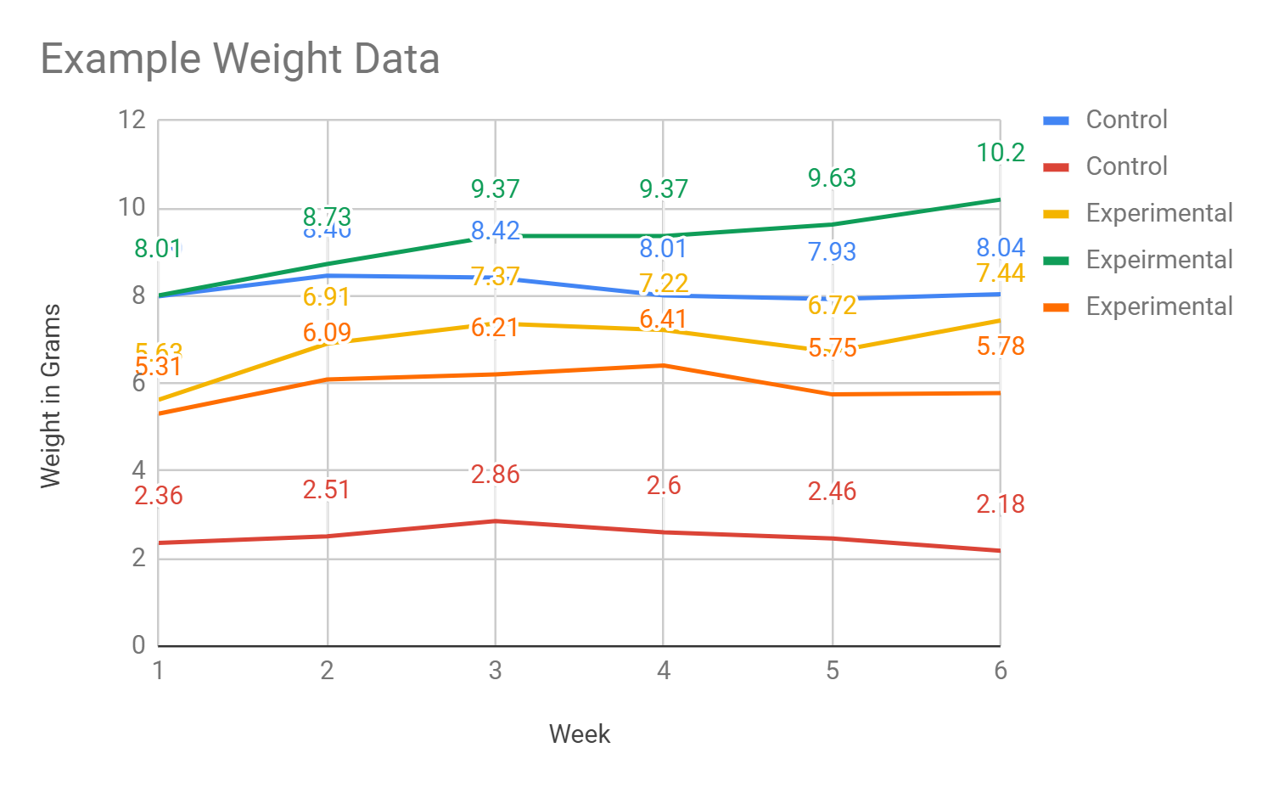

Over the course of the experiment, you will inject the frogs once a week for 3 weeks and weigh the frogs once a week. Weighing the frogs more often than once a week can lead to noisy data as the frogs weight can fluctuate a lot over the course of a 24-48 hour period. Try and always weigh the frogs at the same time each day.

# 



Care of Green Tree Frogs(*Hyla cinerea*)

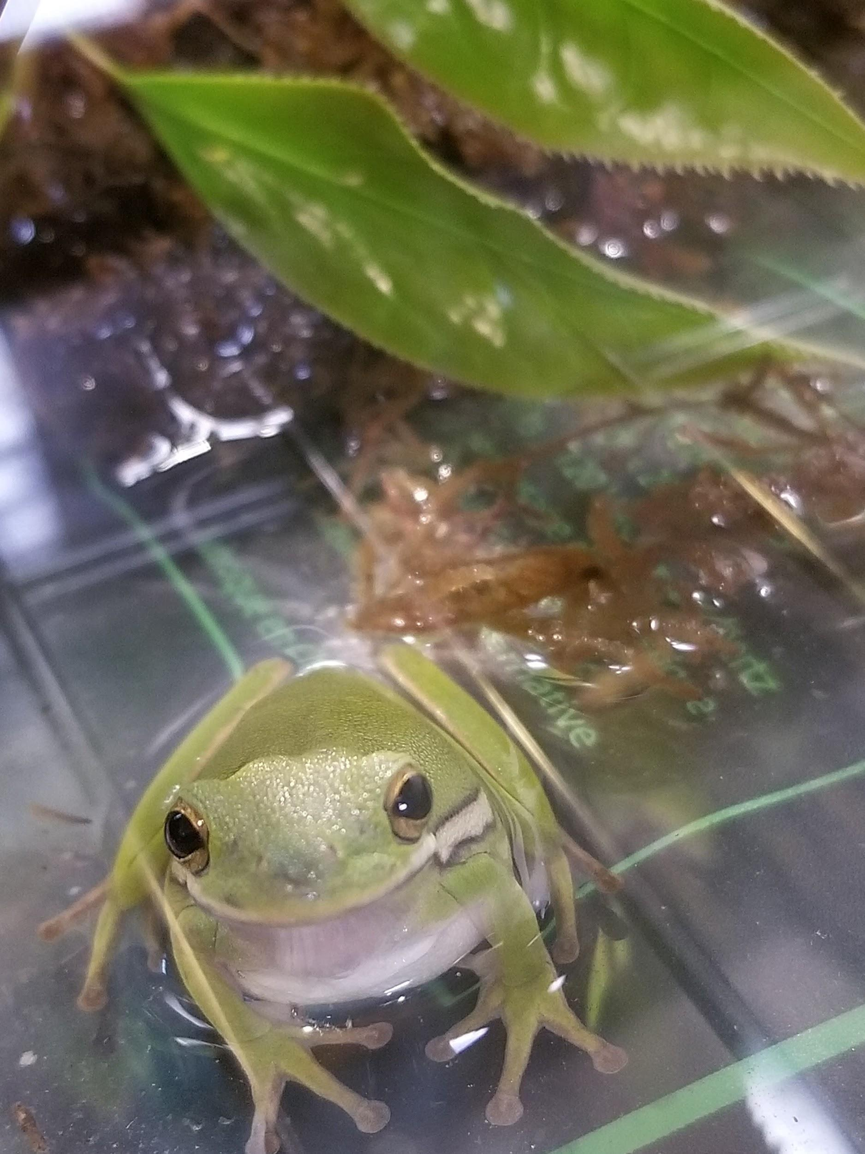

The Green Tree Frog or its scientific name *Hyla cinerea* is commonly found in many parts of the United States. It is an arboreal frog but can be found burrowing in dead plant material on the ground. These frogs are nocturnal so they are most active at night but will still move around and feed during the day. They can survive up to 10 years with proper care. All protocols and procedures follow recommendations from the [NIH Guide for Care and Use of Laboratory Animals](https://grants.nih.gov/grants/olaw/guide-for-the-care-and-use-of-laboratory-animals.pdf) where appropriate.

**Temperature and Humidity**

The frogs should be kept at a temperature ranging from 65F - 85F(20C - 30C). With a temperature around 75F(24C) best. It is ok for temperature at night to drop down to the lower end of the range. These frogs need humidity and water but they are not aquatic. It is best to keep a small water bath in the cage for the frogs and also line part or all of the bottom of the cage with moss or shredded coconut husk because it can hold water and the frogs will not try and eat it. Water the moss or coconut husk at least once a week. Make sure the water is treated if tap water or unchlorinated.



**Water**

All tap water must be treated. Follow the instructions for the amount of water treatment to add to the tap water. Generally, you can’t add too much(though don’t go overboard) and the water becomes dechlorinated in minutes.

**Feeding**

These frogs eat mostly living insects and worms. Crickets and roaches are a great food source. Feed the frogs every 2 days at most depending on the number of frogs and the size of the frogs. Bigger frogs can go longer without food.

**Determining the Sex**

Tree frogs are notoriously difficult to sex. Males often have a pouchy neck and “sing”(though on rare occasions females have been known to sing). The singing sounds like a teeny dog barking.

**Habitat**

Habitats need to be completely enclosed as Green Tree frogs are great climbers and jumpers. If possible include sticks and branches with leaves attached for the frogs to climb and hide on. These frogs can stick to the side of their enclosure and will often climb up the side and stay near the top.

**Anesthesia and Euthanasia**

In order to anesthetize these frogs you need to let them sit in 0.04%(400mg / liter) benzocaine usually by placing them in a mason jar or small container. This can take 10-20 minutes depending on how much of their skin is in contact with the liquid. Be careful not to let the frogs stay unconscious in the liquid for too long as they can die. After the frogs become unconscious move them to a clean container with a minimal amount of water on the bottom(it should not cover their face or head). Frogs usually recover in 30 minutes - 1 hour but in some instances can take up to 4 hours or more. If a frog is severely injured you can keep it submerged in the 0.04% benzocaine solution for 2 hours or more and it will not recover consciousness. They can then be buried or flushed down the toilet.

**The Experiment**

The experiment is composed of two sets of 3 frogs. One set of 3 frogs should be the control to measure how the frogs grow without the gene therapy. The second set of frogs is the ones that will receive the IGF-1 gene therapy and hopefully grow in size. The most important part of this experiment is that you treat both sets of frogs equally. If you have one set of frogs in the sunlight make sure the other set is also. If you forget to feed one cage don’t feed the other. Feeding the frogs is also very important. You need to make sure you feed the frogs as often as possible but at most once a day. This helps the frogs grow. 

Once you receive your kit you can’t start genetic engineering just yet. First you need to acclimate your frogs to their new environment. That means that you need to put them in their cages with food, moss and water. **Give the frogs around a week to acclimate to their new environment.**

**Treating Water**

**DO NOT USE CHLORINATED UNTREATED WATER WITH THE FROGS**

Take a tube of water treatment solution and add it to 100mL of water(use the 50mL measuring tube to measure out 100mL) this water just be ready for use almost immediately

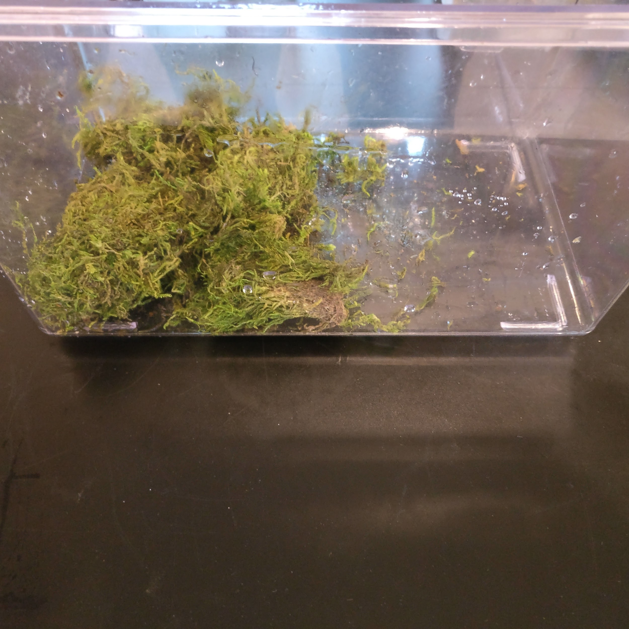

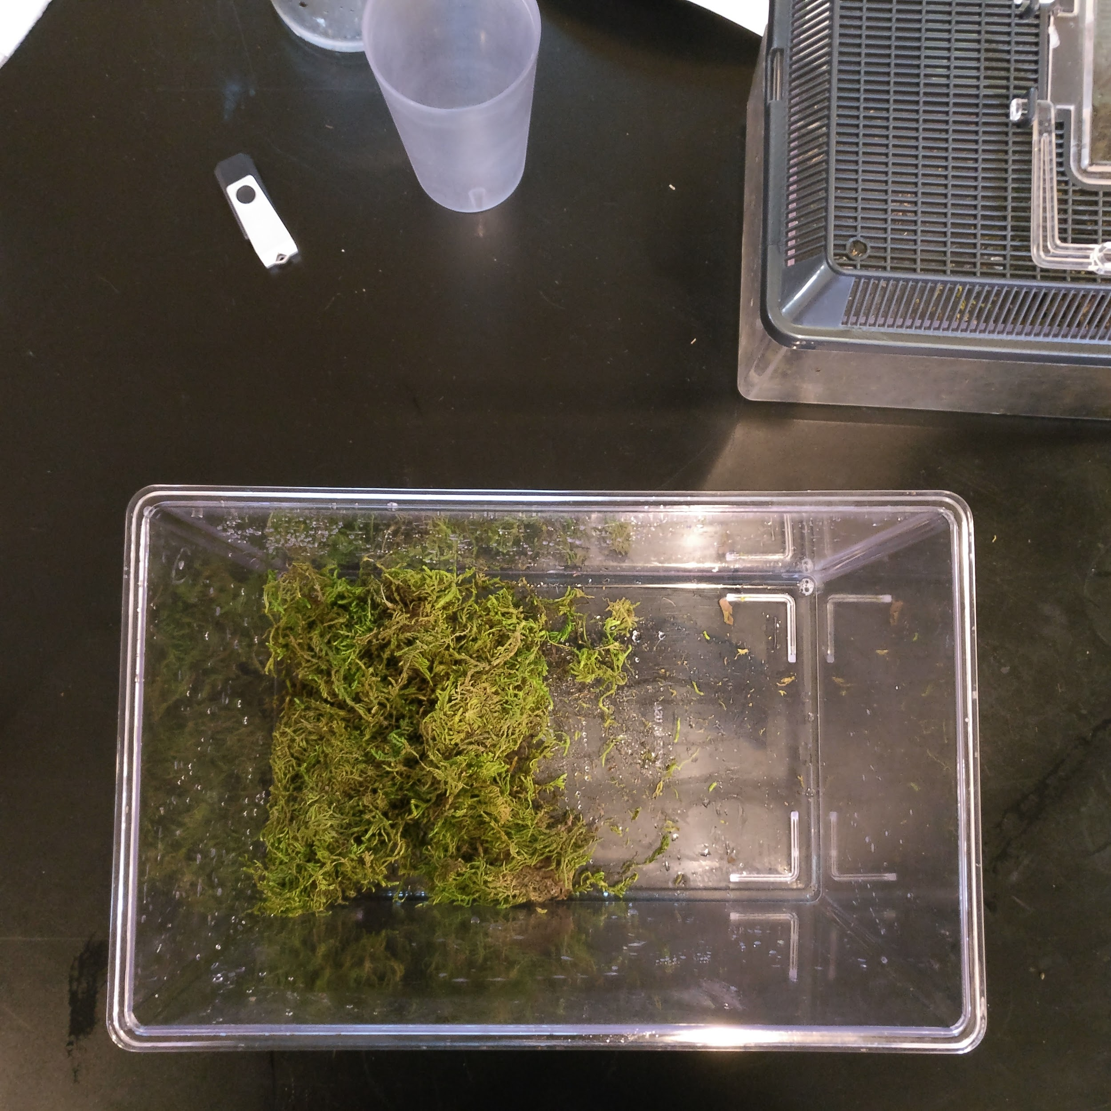



**Making Up The Cage**

1. Empty moss into the cage
2. Add 100mL of treated water and let it soak into the moss(there shouldn’t be excess water covering the unmossed part of the cage, if there is empty it out or try and soak it into the moss)
3. Add 3 frogs to each cage
4. Weigh out and add ~0.6g(600mg) of crickets per cage
5. Feed the frogs once a day(generally they eat at night) if the crickets start to build up in the cage give them a day or two to eat the crickets before adding more. Make sure you always do the same thing in both cages.

**Practice**

It is important that before you inject frogs that you perform a few practice injections. This is to find positions in which you can comfortably hold the needle and perform the injection. Trying to do an injection without practice will increase the chances of failure and of causing harm to the animal.

In the kit we have included a piece of styrofoam and a syringe and needle to practice on.

Draw in some water into the needle and practice holding the styrofoam with one hand and injecting with the other. Do it a few times, make sure your grip is comfortable. A good way to hold the syringe is to put your index and middle finger around the syringe and in front of the guard. Use your thumb to press against the guard and hold the syringe tight. This makes it easy to transition to pushing the plunger to make the FLEEB injection.

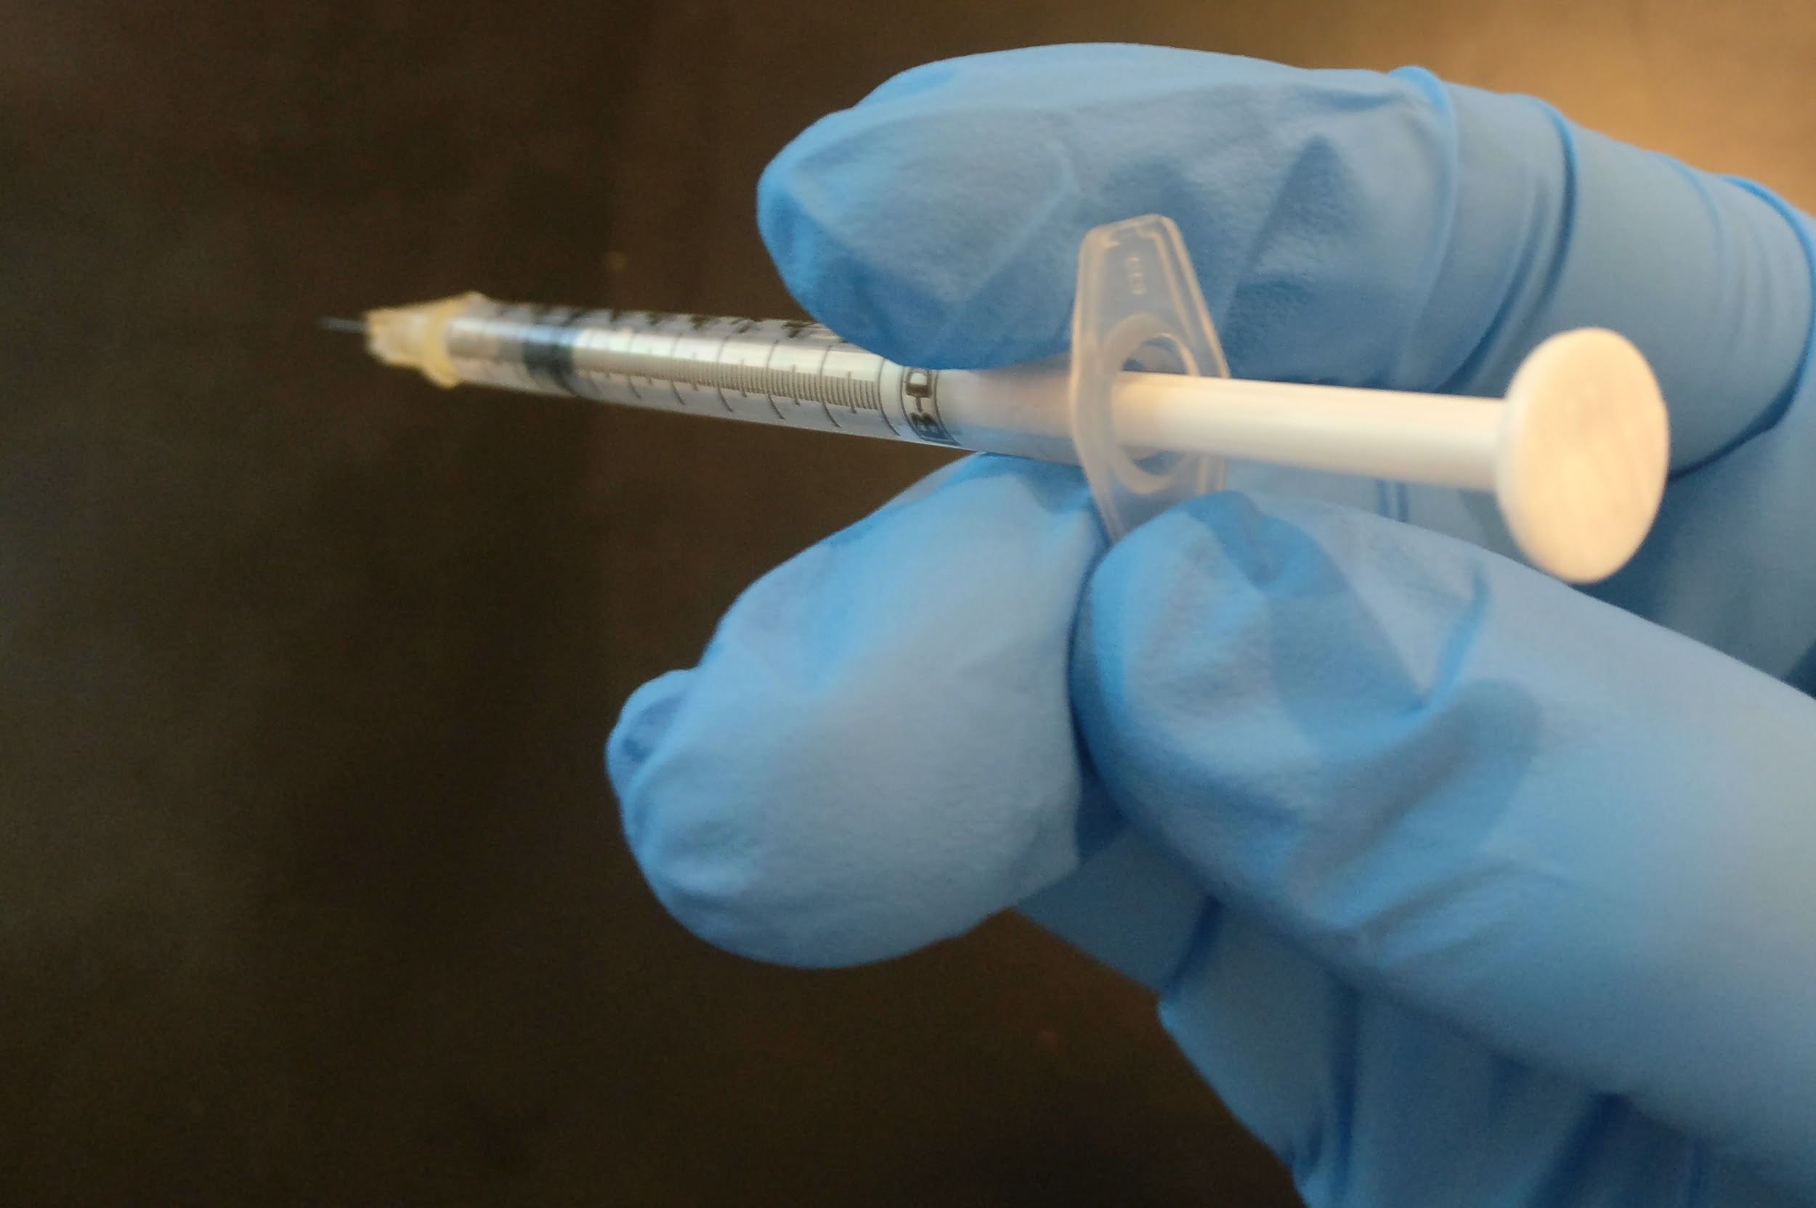

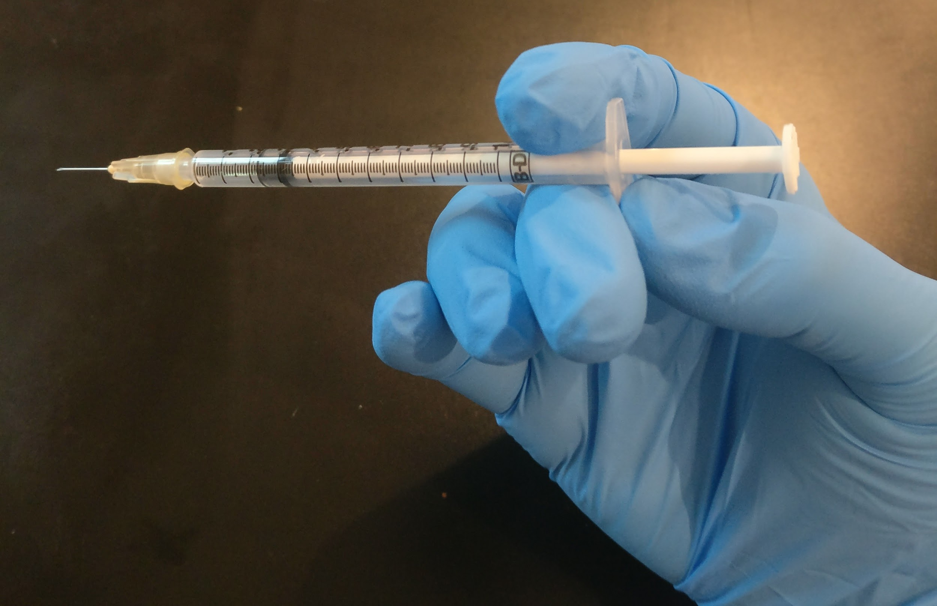

Once you have this technique practiced a few times you are ready to start your first frog injections.

**Frog injection**

First you need to anesthetize the frogs. Measure out 300mL of water and add one tube of benzocaine directly to the water. Use the small plastic container and lid provided.

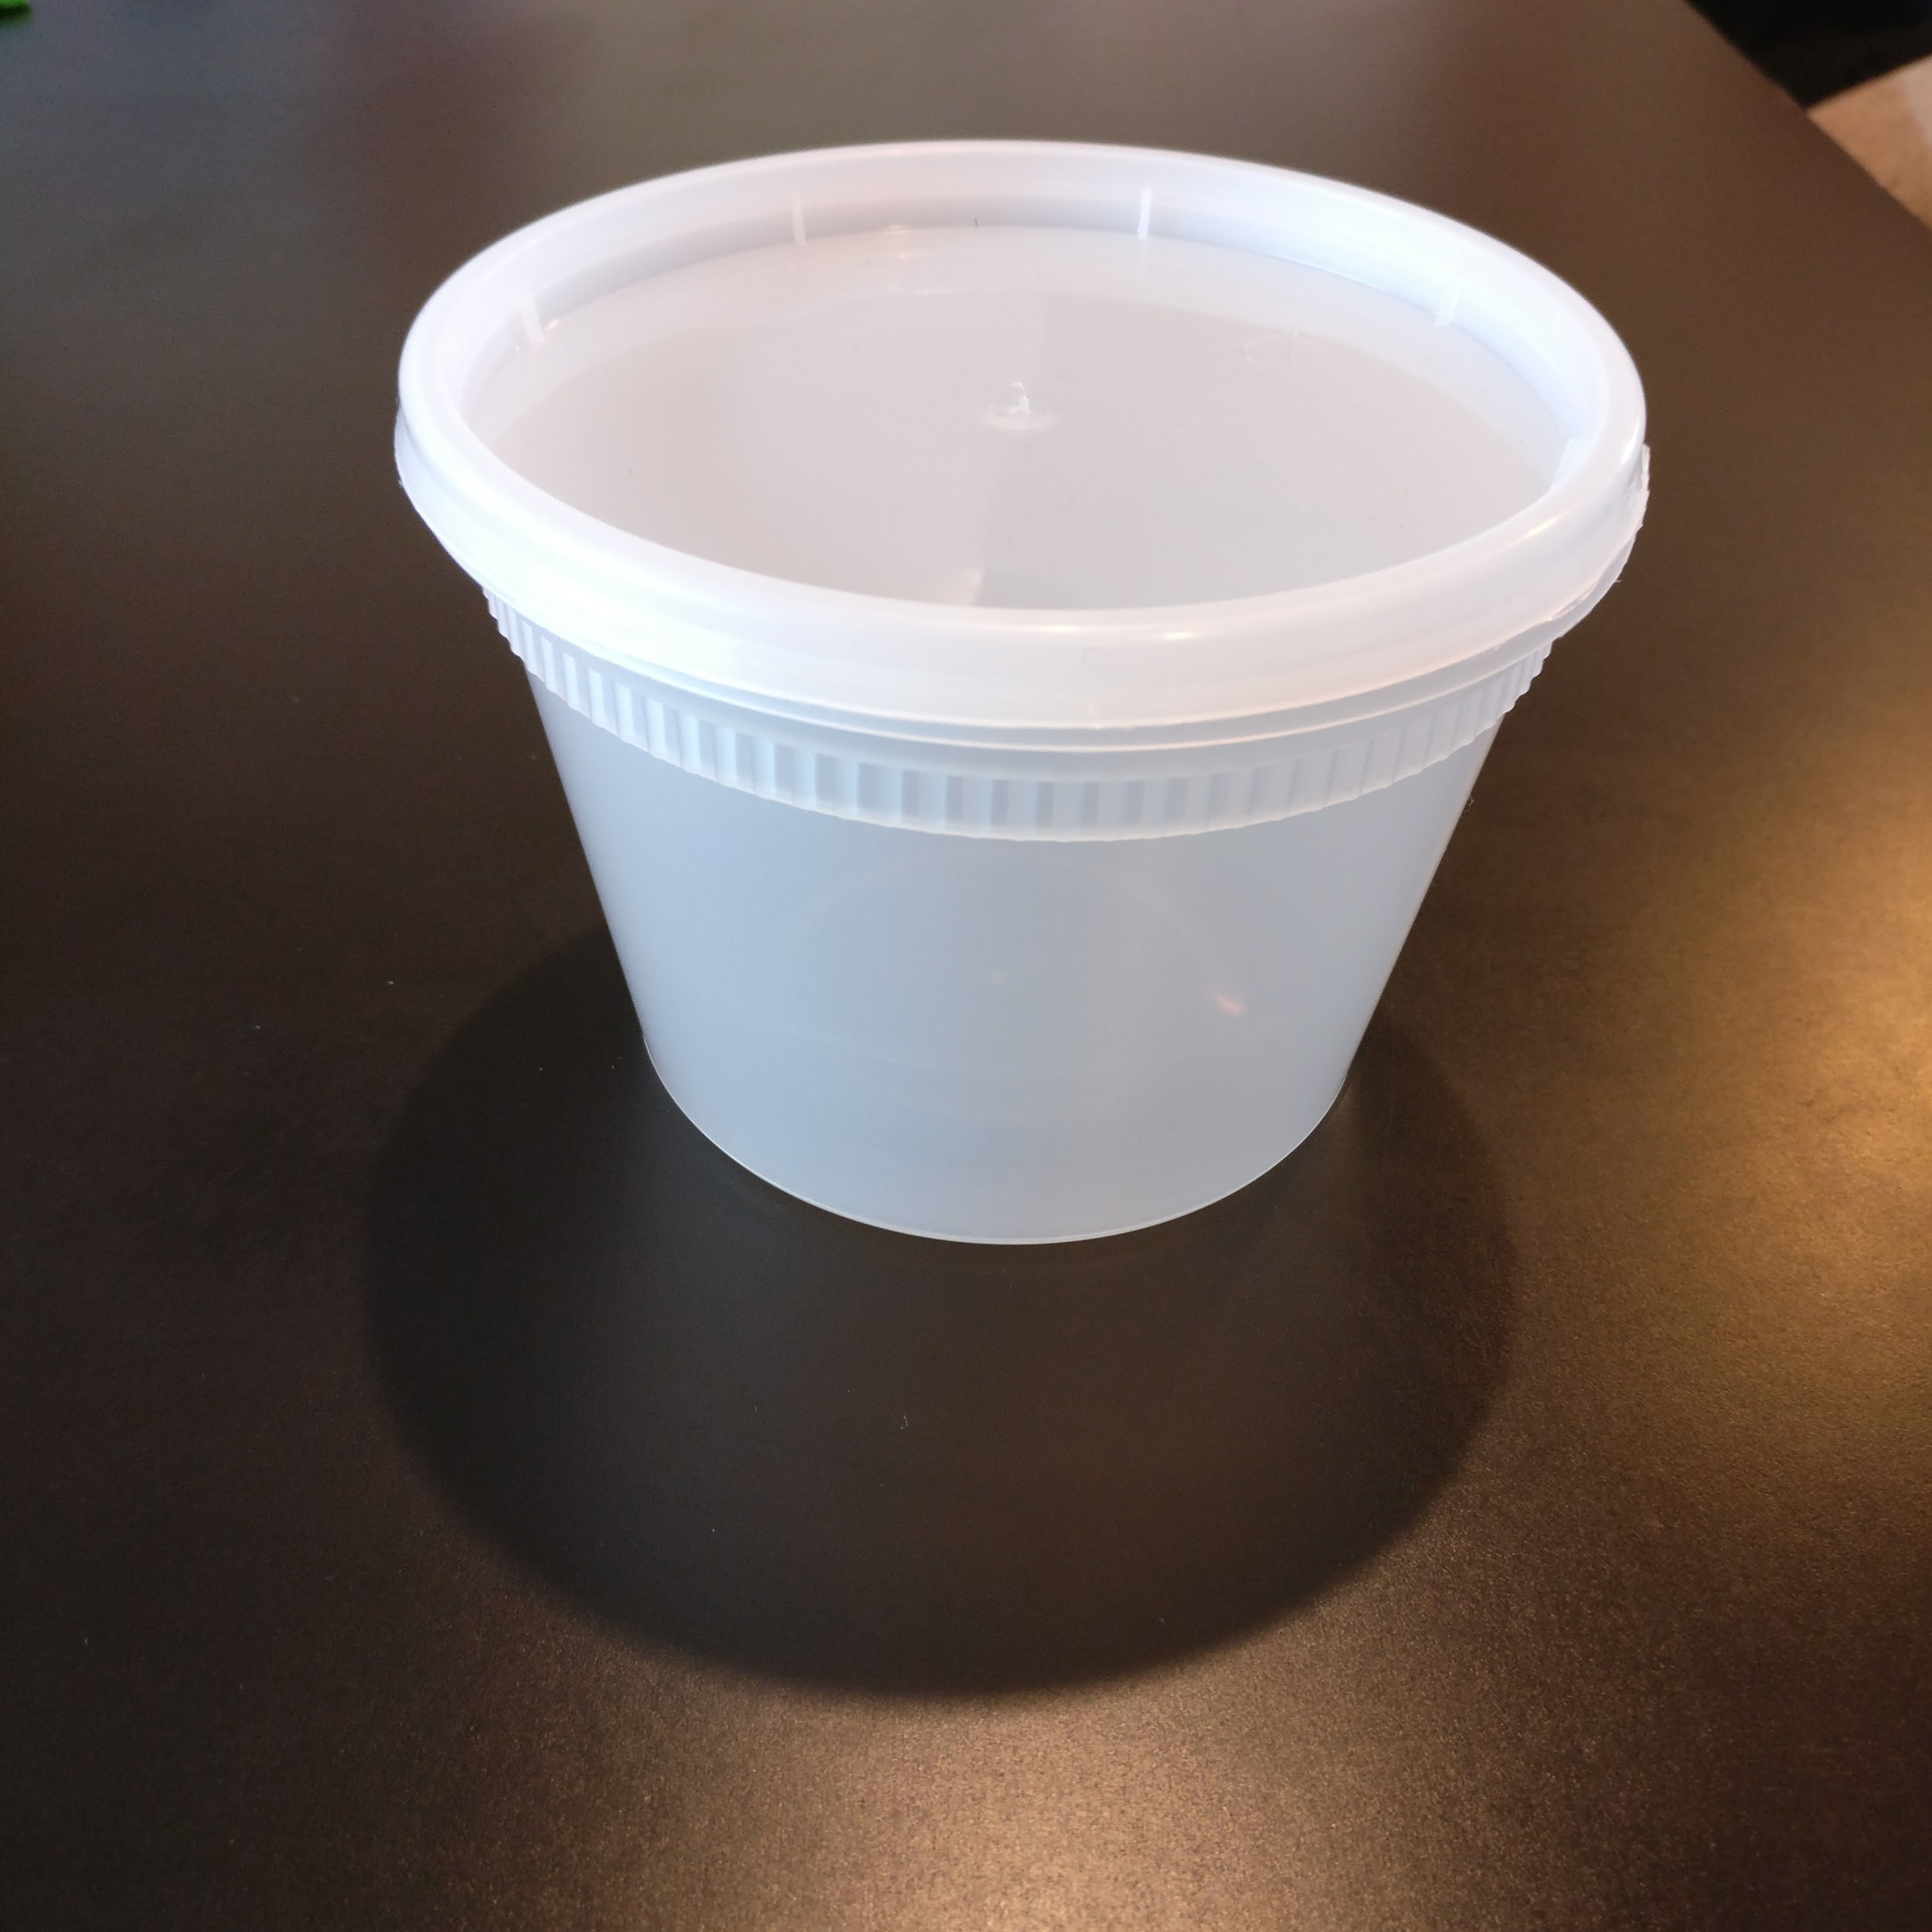

Place three frogs at a time into the benzocaine water and keep the lid closed. The frogs will become anesthetized and unresponsive in ~5-10minutes. Be very careful because they can die from prolonged exposure to the anesthesia.

See this video: <https://www.youtube.com/watch?v=wMGYZcKYB_c>

Once the frog is unconscious weigh the frog on the scale and take a picture of the top and bottom so you can match them later. Keep a spreadsheet with the weights and pictures from each week.

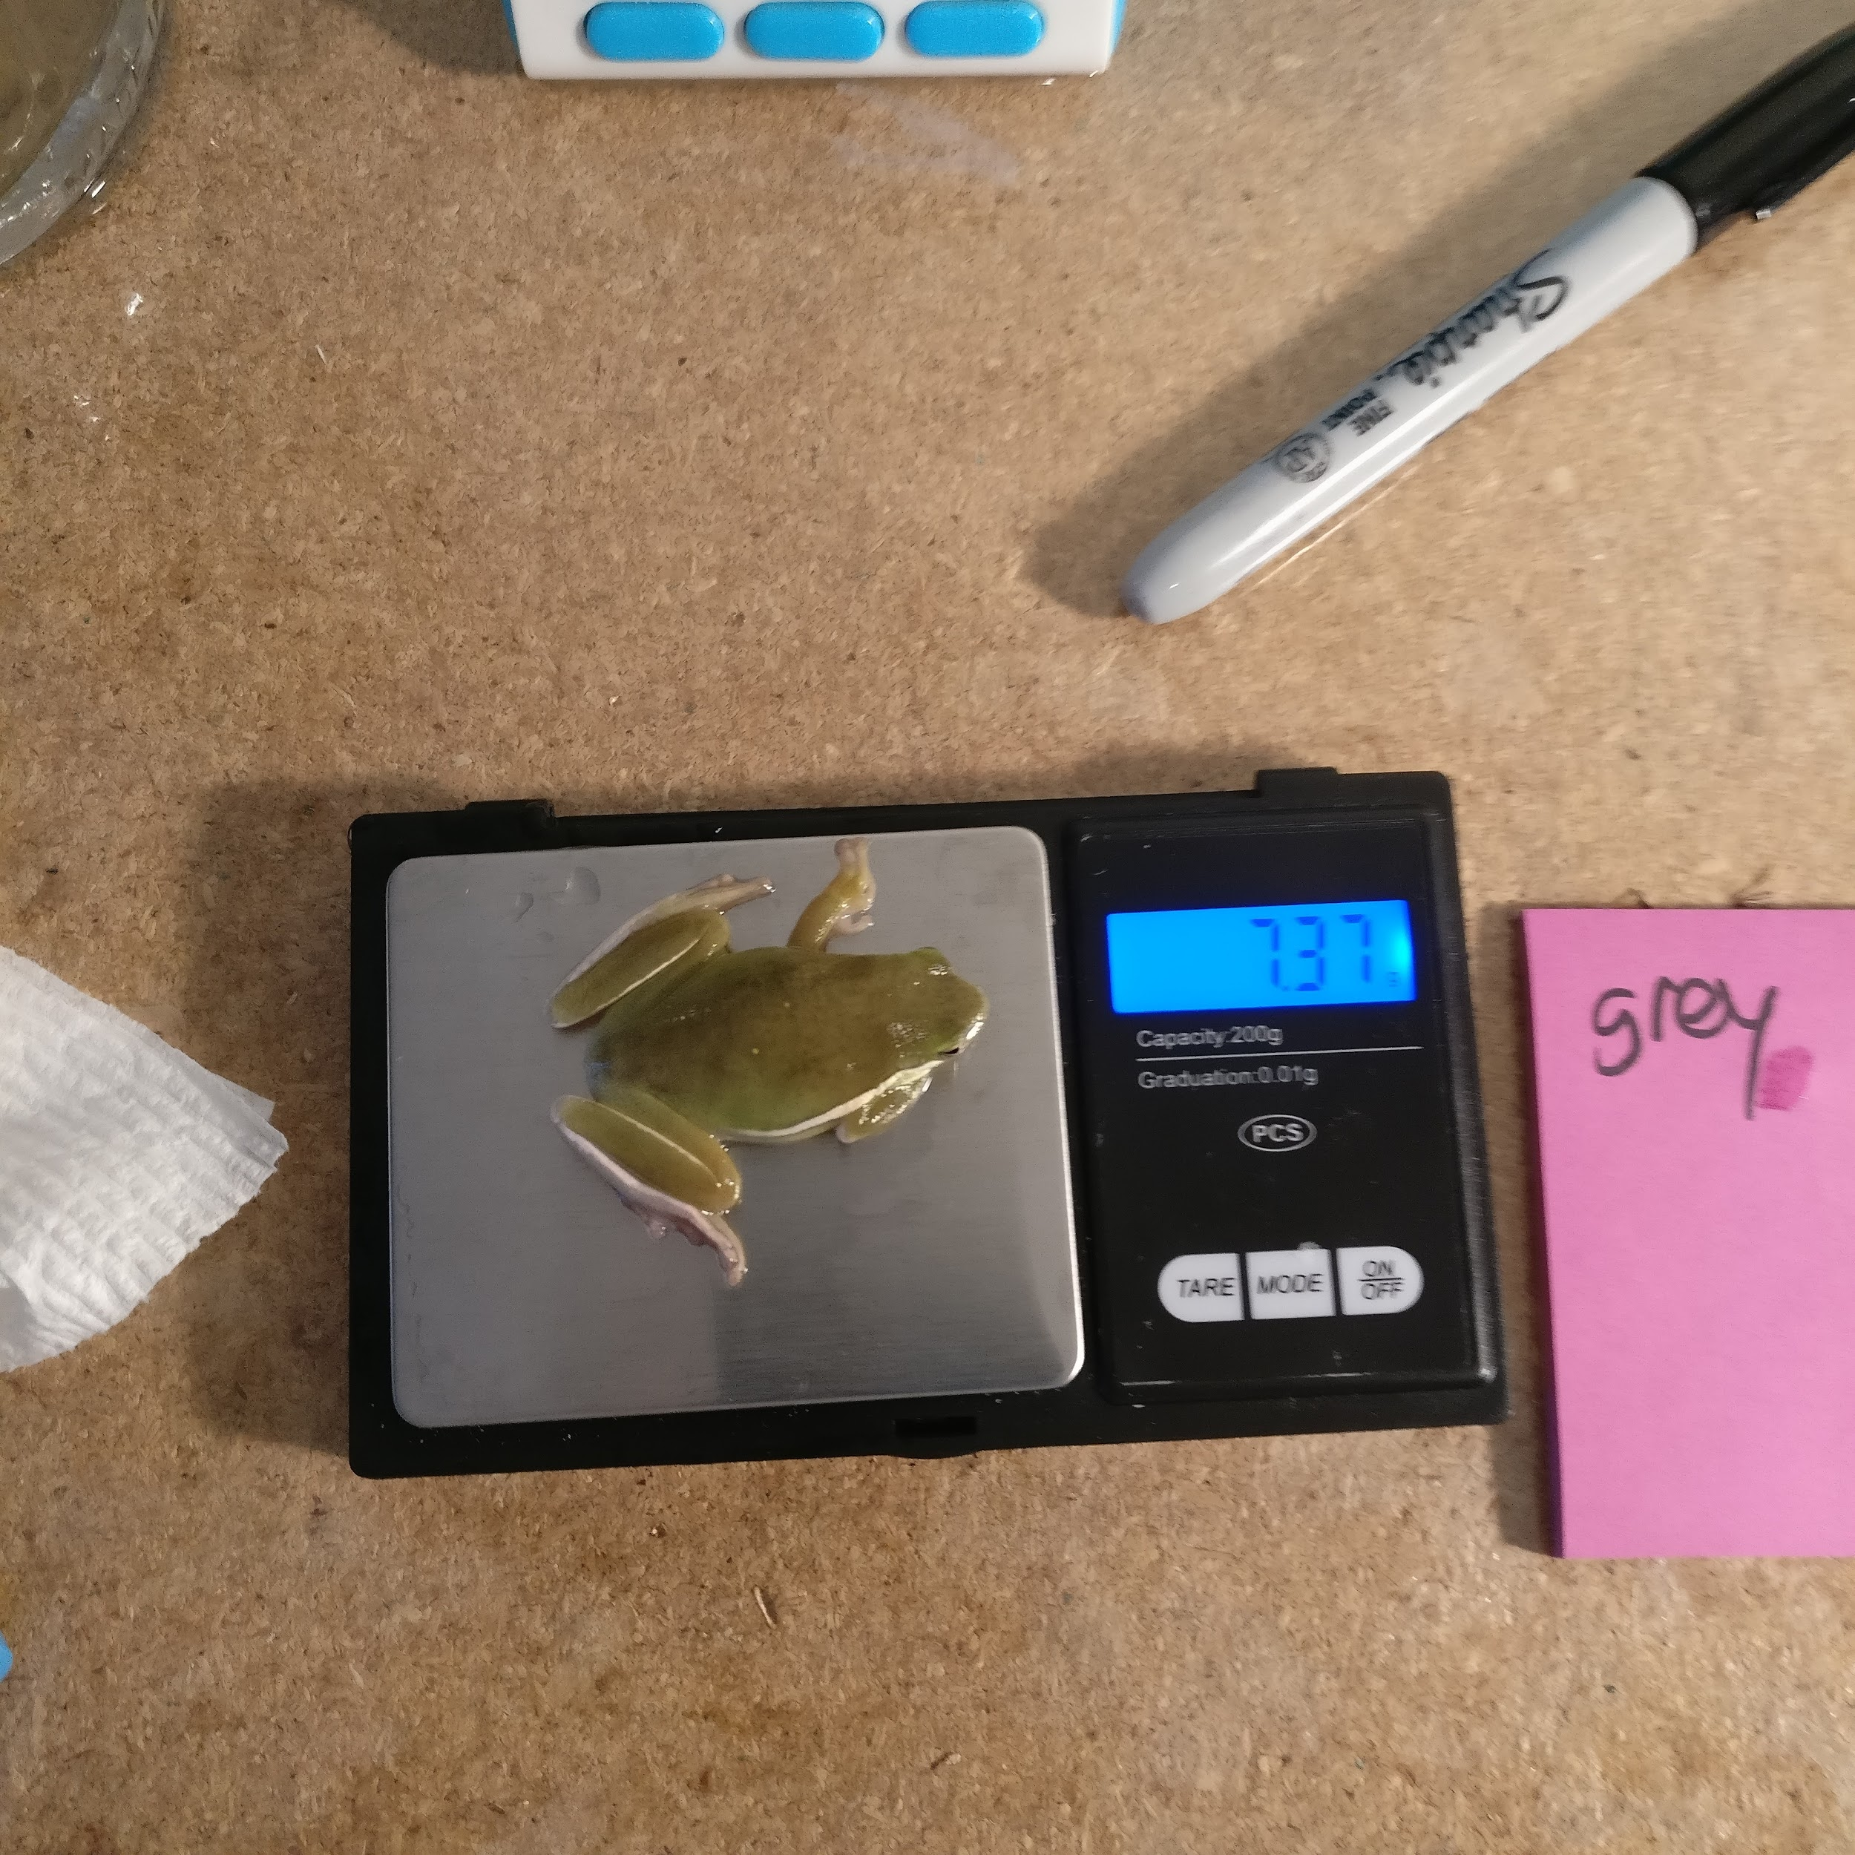

You want to be consistent in your injection and inject the same place in the frogs each time. We have found that intramuscular seems to work better and so recommend this type of injection. The biggest muscle that is easiest to access and inject are the muscles in the leg and thigh of the frog. Injection all 200uL at a reasonable speed. See this video: <https://www.youtube.com/watch?v=36KQ7PGHwHI>

# ProtocolFooter.png

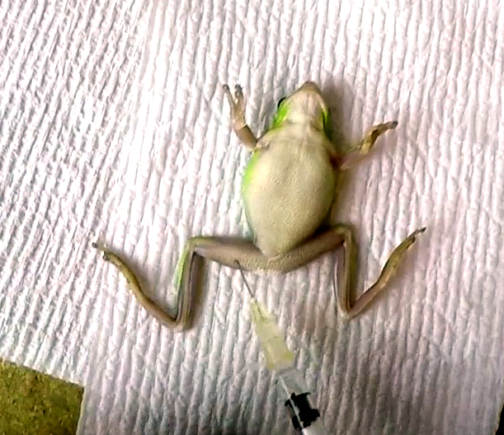

Be careful though because the femoral artery is in the vicinity and is bluish in color. If you puncture the artery the frog will survive but will suffer internal bleeding in the leg and could cofund results.

After the injections rinse the frogs off in distilled and place them back in the cages. They should wake up in 1 hour but sometimes can take up to 4 or 5 hours.

# 

# ProtocolFooter.pngProtocolFooter.png

## **Check Us Out Online**

<http://twitter.com/TheODINInc>



<http://youtube.com/c/TheODINInc>



<http://facebook.com/TheODINInc>

